## The Buffered Delineator Tool

The Buffered Delineator tool works much the same as the Delineator tool with an added buffer zone. It can be manipulated to the shape you need and you can change the delineator.

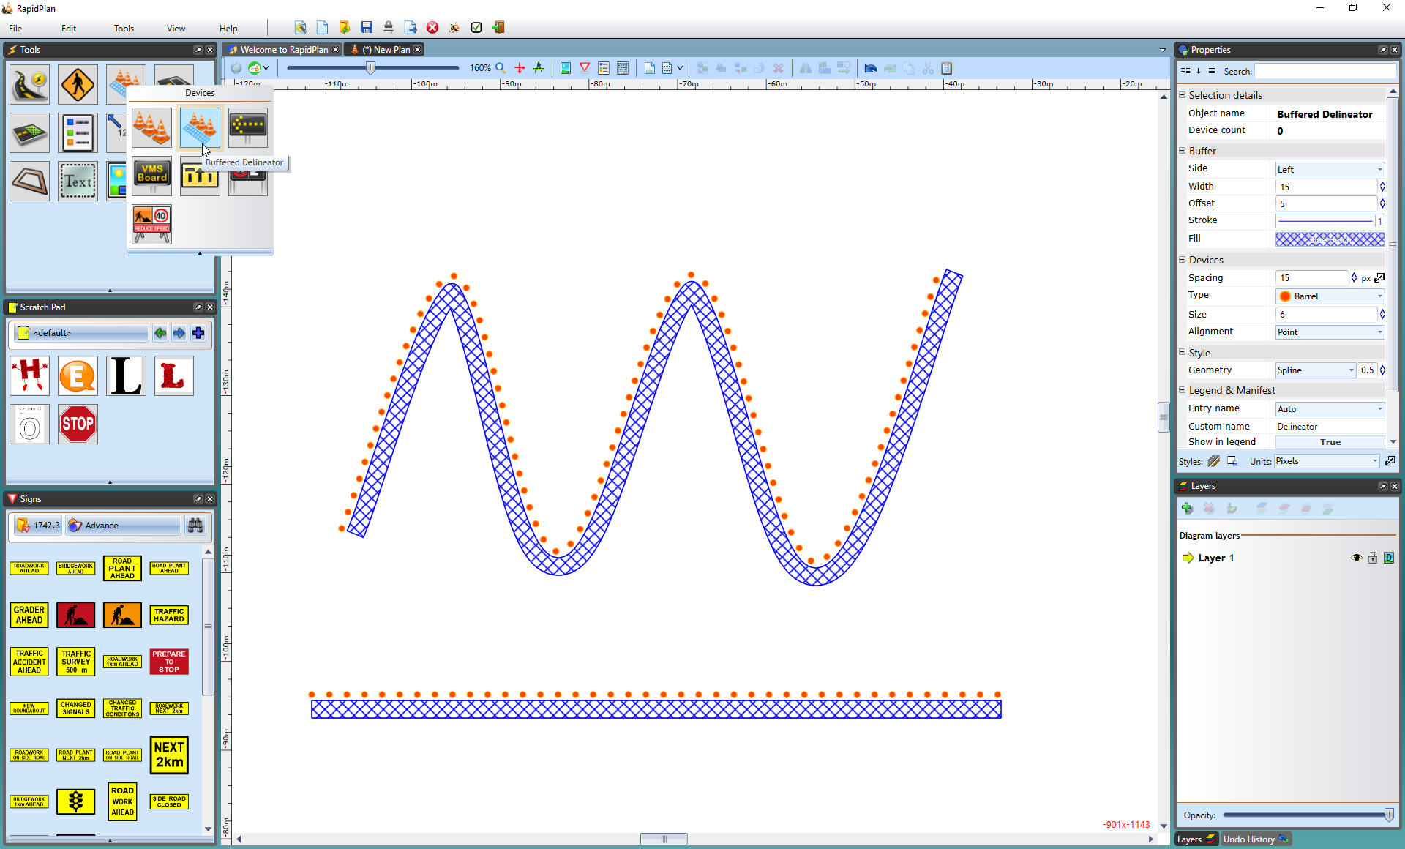

The_Buffered_Delineator